Human machine interaction and ergonomics are important.

Ergonomics: Application of scientific information concerning objects, systems and environment for human use

Human Computer Interaction: Discipline concerned with the design, evaluation, and implementation of interactive computing systems for human use

**Goals of usability studies:**

* **effectiveness: accuracy and completeness with which users achieve specified goals**
* **efficiency: it has to be fast and not tiring**
* **users’ satisfaction: comfort and acceptability of use**

Preprocessing tasks:

* edge enhancement
* colour separation
* data reduction
* movement detection

saccades: moving eyes

fixations: reading

Stroop effect: demonstration of interference in the reaction time and success rate of the task.

2 colors that generate white when combined are complementary colors.

Saturation: how much white is present

**Gestalt Laws**

* **Gestalt means pattern**
* **These 7 rules describe the way we see patterns in visual displays:**
  + **proximity**
    - **things that are close together are perceived as a group**
  + **similarity**
    - **human brain tends to perceive similar elements as grouped**
  + **continuity**
    - **smooth and continuous visual elements are more likely to be perceived as an entity than ones that contain abrupt changes in direction**
    - **important when drawing diagrams with nodes and links between them**
  + **symmetry**
    - **brain tries to group symmetrical figures**
  + **closure**
    - **brain tends to close contours that have gaps in them**
  + **relative sizes**
    - **smaller components of a pattern are perceived as objects whereas the bigger components are seen as background**
  + **figure and ground**
    - **figure is a pattern perceived as an object that is being the foreground**

Haptic interaction: interaction that users perform using muscular movement

Tactile interaction: interaction that users perform more with their skin senses along with muscular interaction, you feel the click

**Fitts’ Law**

**As human movement occurs, movement distance and the size of the target has significant impact on movement speed and performance**

**t = a + b log2(distance/size+1)**

**a and b are constants, different for different input devices**

Memory

3 types of memory

* sensory memory
  + acts as buffers for stimuli received through senses
    - iconic (for visual stimuli)
    - echoic (aural)
    - haptic (touch)
* **short term memory**
  + **acts as “scratch-pad” for temporary recall of information**
  + **keep pop-up messages on screen because people forget**
  + **it is necessary to carry “temporary information” and “state knowledge” between these states.**
    - **bank teller examining your ID and enter to computer**
    - **looking manual of washing machine and programming knobs**
    - **remember error message from previous screen**
    - **voice operated menu in electronic banking**
  + **what to do**
    - **exploit chunking (533-435-8385)**
    - **support visual aids**
    - **provide important information from previous screen to current screen**
* long term memory
  + the repository for knowledge
  + information in long term memory and organization in brain determines mental model
  + long term memory creates mental model

Recall: information has to be remembered

Recognition: information is provided an all a person has to do is choose it

Perceptual process: anything that is seen must be processed and this is not free

processing difficulty depends the complexity of the visual scene and on our previous memory of the scene

Mental model: mental image that users develop is usually influenced bby their real world experiences and their experiences with other objects or applications

* cameras are turned on, mental model about the class become more realistic
* as we learn, we look for patterns
* what happens when using pointers, everyones understanding, mental model is different
* ---
* mental model of a device is formed by its actions and visible structure
* we can predict and explain user behaviours by understanding mental models

mental model about faucet is turning right or left

refrigerator control: what is the mental model necessary to control a refrigerator?

* Vestel:
* A close-up of a timer

  Description automatically generated
* mental model is formed by left right corresponding to top and bottom
* mental model thinks two different compressor but there is actually one:
* A diagram of a flowchart

  Description automatically generated
* Beko
* 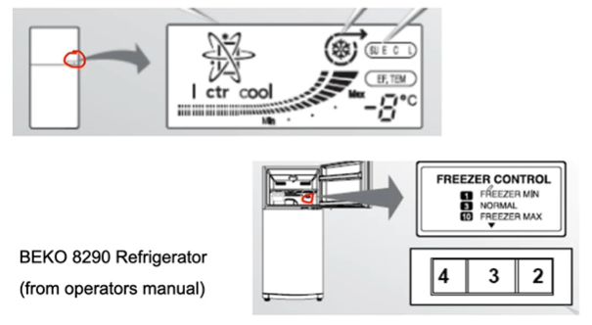
* A diagram of a flowchart

  Description automatically generated

Improper mental models will often result in unexpected problematic uses

If mental model results in unexpected outcomes, we develop new mental model

Affordance: If text is blue, it is hyperlink. If door handle is vertical, it means pull.

Mapping: yukarı=artış, aşağı=azalış…

attention may increase success rate

big changes are more noticeable

3 types of visual reference:

* ICON (simple visual relationship)
  + recover language problems
* INDEX (indirect reference) ---> not choose often
* SYMBOL (designer chosen)

in order 3:

Principles of metaphor use

* immediate recognition
  + what is this? question shouldn’t be asked
* generality
  + image of cat shouldn’t represent our cat, represent all cats
* associativity
  + metaphors in user interface are perceived as individual pieces of a bigger system
    - > doesn’t mean so much
    - >, >>, << mean play forward backward together
* characterization
  + basic characteristics of object should be used to relate a metaphor to real entity, not through details
    - I should put glasses directly, not the person with glasses
* communication ability
  + designer and user of a metaphor should have similar cultural and educational backgrounds

not too big text, not images for complex descriptions, not too much consistency, clear relationship, language and culture,…

Correct design method:

* If concept has strong base, relates to a familiar object understandable by looking, ICON should be used
* If concept is used several times, SYMBOL or INDEX
* If concept describes more abstract process or state change, LABEL
* Don’t mix ICON, SYMBOL, INDEX

Incremental Abstraction:

* Incremental abstraction: start from image, slowly reduce details, it becomes icon
* Level of abstraction should be determined based on topic, screen choices, user characteristics

Coordination:

* Start drawing metaphors after all initial images are obtained
* same perspective, same abstraction level…

Text

* lowercase, serif fonts are better

Principles of User Centered Design: modified version of structured software engineering, treats users as members of software development team and collaborates in every stage of development

* Understand users
* Task analysis
* Iterative approach
* Real user tests

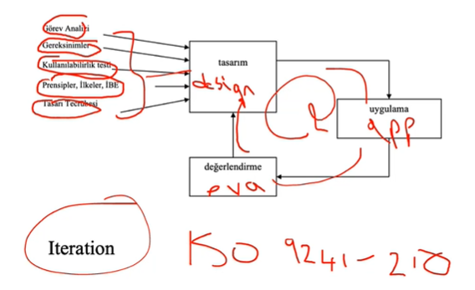

**General Guidelines in Interface Design**

Guidelines have been established for how windows in a gui should be designed

Golden rules – heuristics

Jacob Nielsen principles

Idiomatic design 🡪 application of a design that is not necessarily intuitive but simple and natural to learn.

Anticipation: applications should attempt to anticipate the user’s wants and needs. bring to the user all the information and tools needed for each step of the process. but don’t make user just next next next. There is some freedom needed.

Autonomy: There are rules but user in charge. If there is no boundary, you are trapped, you don’t know what to do.

* keep users aware and informed

Locus of Control: term that is used to describe who is initiating the interaction, who is the boss

A superior interface should be designed so that all its components are consistent, both with other interfaces familiar to the users and within the application itself

* between-application consistency
* within-application consistency

Different levels of consistency by levels

* interpretation of user behavior
* invisible structures (such as connecting 2nd screen)
* small visible structures (such as grids)
* the overall “look” of a single application or service
* a suite of products (Microsoft office)
* in-house consistency (companies should be consistent in different applications)
* platform-consistency (Linux, macos, ios, android…)

don’t be too consistent. It will look like military base. There is some differentiation needed.

make objects act differently look different.

Form and functionality

* form and functionality of the interface should be natural to user

hover style is bad because you don’t know if there is hover before you check so.

flexibility and efficiency of use

* keyboard interaction is faster than mouse
* shortcuts (accelerators)

accommodating levels

* superior interface is adaptable to both in its structure and its ability to be customized for different levels of users
  + for example windows icons on desktop in windows are organized when they are created but changeable by user.
* different ways to complete the task

Efficiency 🡪 superior interface should make task completion efficient

look user’s productivity not computers

keeping user occupied

* any time user is waiting response, time waste

defaults

* fields containing defaults should come up selected
* use “standard”, “use customary settings” …

superior interfaces consider color blind population

you should use secondary cues

red sign and “stop” word

explorability: don’t guide too much

easy stay – easy leave: give a way out, don’t make user feel trapped

Fitts Law

* use large objects for import
* use active regions, 1 pixel boundary can result in slow-down

latency reduction

* wherever possible use multithreading to push latency into background
* display animated hourglass for long jobs
* click 🡪 50 ms
* if you wait, acknowledge the user

readability:

* high contrast
* black text on white
* pale yellow background
* avoid gray background
* don’t bold captions

selection is better than data entry

entered values should not be erased when returning back from a next screen

form based data entry: similar to paper forms, multiple information in one screen

dialog based data entry: question-answer, slows down but prevent error

data entry mode should be shown with blinking, cursor etc. about the modes

controlling dialogue

* main screen
* consists of
  + menus and tabs
  + toolbars
  + command/action buttons

Menu

* recognition rather than recall
* menu tree structure should reflect system behaviour
* menu choices
  + pull-down
    - horizontal menu along the top of the menu
    - vertical choices under each of these major categories
* use single understandable word
* submenu should be readable together with top menu
* **menu items should be ordered based on the following structure**
  + **if there is a platform standard, comply with it**
    - **they have certain places**
  + **frequent tasks should come to top and left**
  + **former tasks should be placed before latter**
    - **file open then file close**
    - **because you open before close**
  + **if there is chronological order follow it (hour, year, date, semester, etc.)**
  + **if none applies, use alphabetical order**

TV Menus

* can open to sides
* keep the title
* CURRENT MODE information should stay on screen

Horizontal menu

* should show the “visual structure” of the application
* cascading menu should be <= 3 levels
* group max 7-8 entries

send feedback when menu item is selected

Guideline

frequency of use

sequence within task: natural order for completing the task (new should be before save or print)

standard order used in windows

chronological

alphabetical

If task is not done immediately, use … 🡪 table…

command action buttons: SAVE, OK, CANCEL… 🡪 DISPOSITION BUTTONS because they often are used to complete a task within a conversational window

they sometimes open dialogue boxes which have their own properties

**Feedback**

transition diagram technique can be used

* transitions from one state to another are caused by events
* events are triggered by user (in case of HCI)

**UAN – USER ACTION NOTATION**

* arrow is clicking, ~ is moving…

Error message types:

* slip
  + mistype
* mistake
  + you don’t know you are wrong

in case of error, show user “ you wanted to do this but this happened”. base the wording on the user’s mental model

minimize input actions (selection fields) and memory load (clues and defaults)

data entry windows:

* form-based
  + mirror a paper-based source document
* conversational
  + differ from form-based windows in that they may contain interaction throughout (clearing, searching, retrieval, display, etc.) rather than only data-entry.
  + density of window
    - design the window so that the density of print and controls is between 25 and 30% of the screen
    - 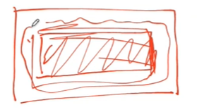

captions:

* name: mert
  + name is caption
  + don’t bold
  + don’t use abbreviations
  + align to left or right
  + show formatting